3 methods to Install Plugins on Jenkins

Jenkins is an open source build automation software that helps us in automating the non-human part of the software development cycle. Jenkins can be used as Continuous Integration server or we can also use it as Continuous Delivery center for any project.

Jenkins in it default self provide functionalities that are useful but these functionalities can be further improved upon & also new functionalities can be added to Jenkins using its extensive libraries of plugins.

In this tutorial, we will learn 3 different ways with which we can install plugins on jenkins server. But before starting, i would recommend that you also read our other tutorials on Jenkins, links are mentioned below,

**1-**[**Install JENKINS on CentOS/RHEL 7**](https://linuxtechlab.com/install-jenkins-on-centos-rhel-7)  
**2-**[**Simple way to change home directory of Jenkins Server**](https://linuxtechlab.com/install-jenkins-on-centos-rhel-7/)  
**3-**[**How to install Jenkins on Tomcat : Complete Guide**](https://linuxtechlab.com/how-to-install-jenkins-on-tomcat-complete-guide/)

# Install Plugins on Jenkins

### **First way**

First way to install plugins on Jenkins is also the most easy & most used way for plugin installation. For this method, we need to login to our Jenkins server, once we are in click on ‘Manage Jenkins’ tab located on left side of the screen,

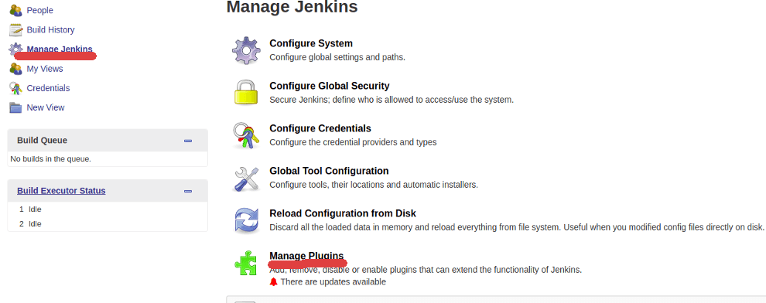

Then we need to select ‘Manage Plugins’ . Now select the tab that says ‘Available’

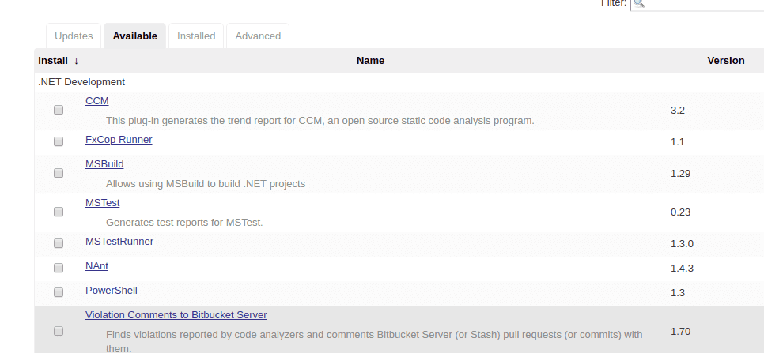

& enter the name of plugins on the search bar .

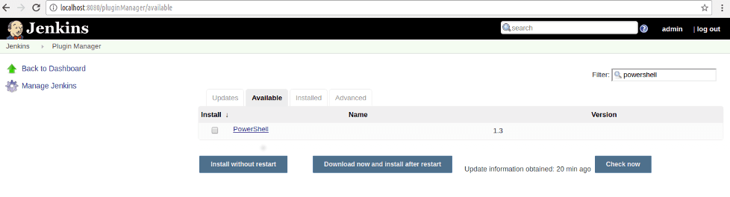

Once the plugin has been located select the plugin & click on ‘Install without Restart’ & that should install the plugin on your jenkins server.

### **Second way**

Second method to install Jenkins is very similar to first way, with exception that we will upload the plugin file on the jenkins server. I will take an example of PowerShell plugin for Jenkins.

You can download the latest PowerShell plugin from the this location (http://updates.jenkins-ci.org/download/plugins/powershell/1.3/powershell.hpi). Plugin will have .hpi extension, now login to jenkins server, then ‘Manage Jenkins’ , then to ‘Manage Plugins’ & select ‘Advanced tab’ , there we will see option to ‘Upload Plugins’,

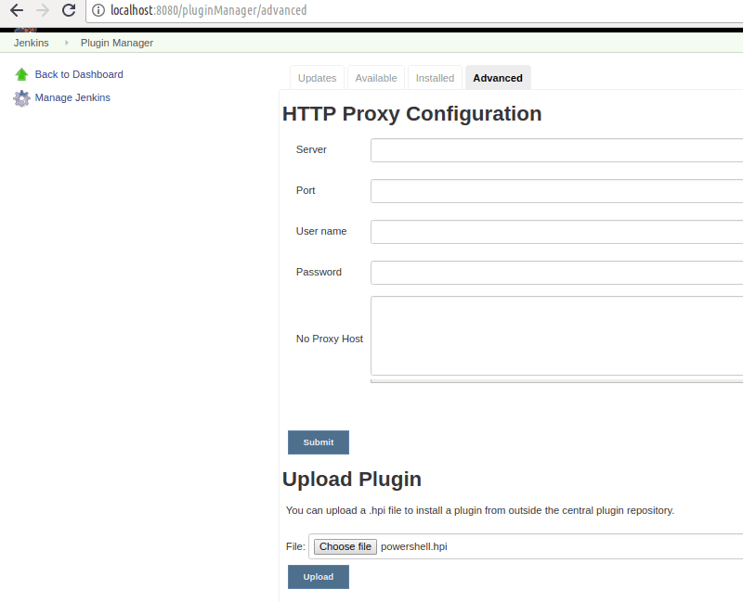Once the plugin has been selected, click on ‘Upload’ to install the plugin.

### **Third Way**

Third way to install plugins on jenkins requires us to manually copy the downloaded plugins file to the ‘JENKINS_HOME/plugins’ folder.

So if you have jenkins installed in ‘/var/lib/jenkins’ directory, than copy the downloaded plugins file to ‘/var/lib/jenkins/plugins’ folder. & than restart the jenkins server, either from terminal using following command,

**$ sudo systemctl restart jenkins**

or from the browser with the following URL,

**http://localhost:8080/restart**

Replace localhost with the IP address of the server. Once jenkins has restarted, you can check installed plugin via ‘Manage Plugins’ screen.